These is my home directory for both of my linux machines, I transferred both of the text files onto the server by connecting by IP address. I had an issue for a long time connecting due to the network adapter configuration. I was able to configure it after researching it and then using WINSCP to transfer the file.

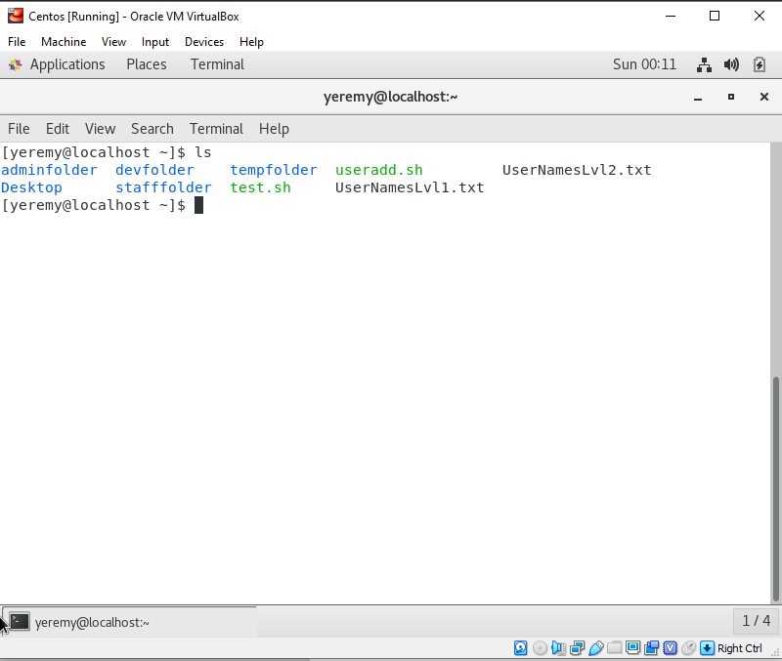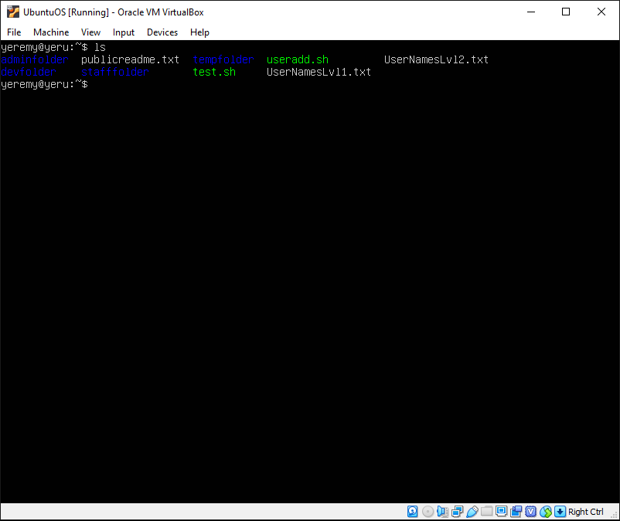

This is my Readme files I created in all the folders that the users will have access to. Each one if different for the groups.

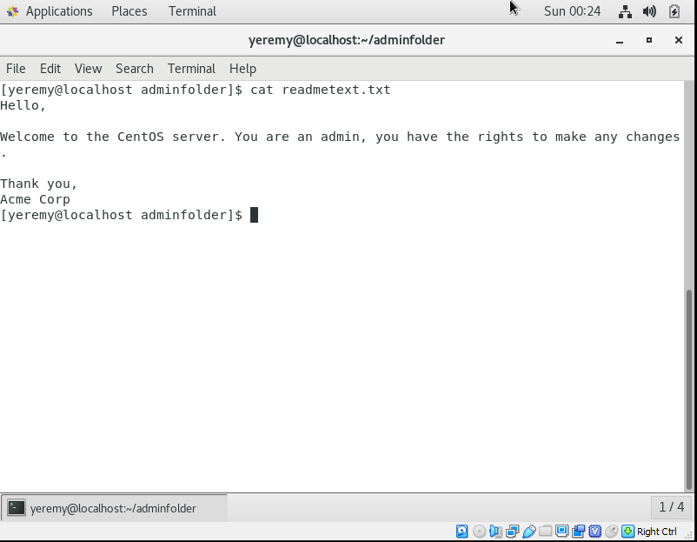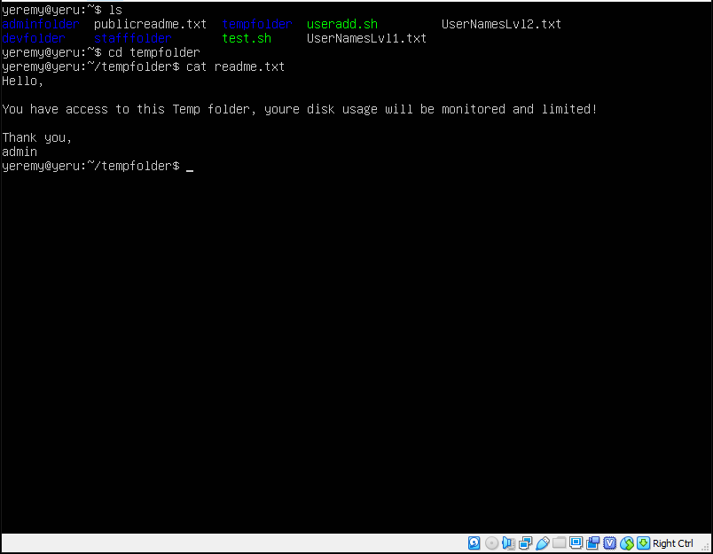

This is a list of the users I picked from the list. I decided to take 20 users from each list and write a script that will add each user to the list.

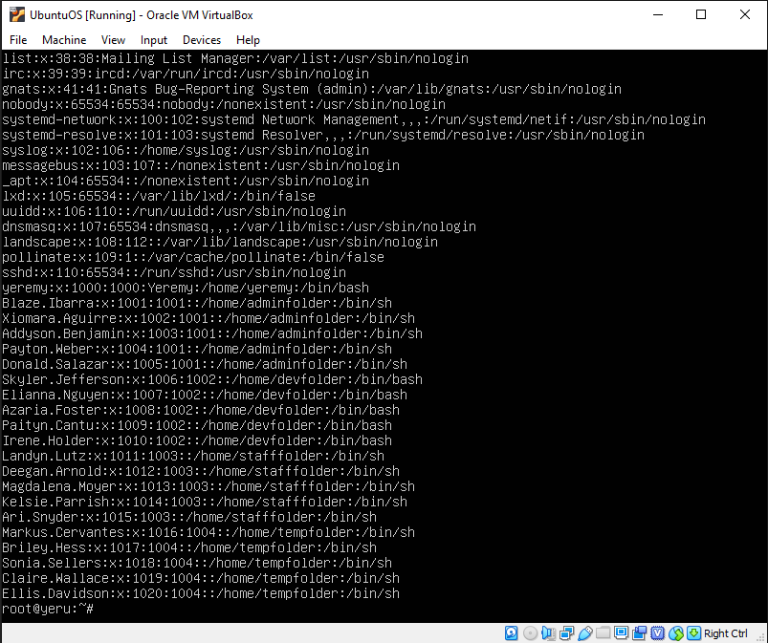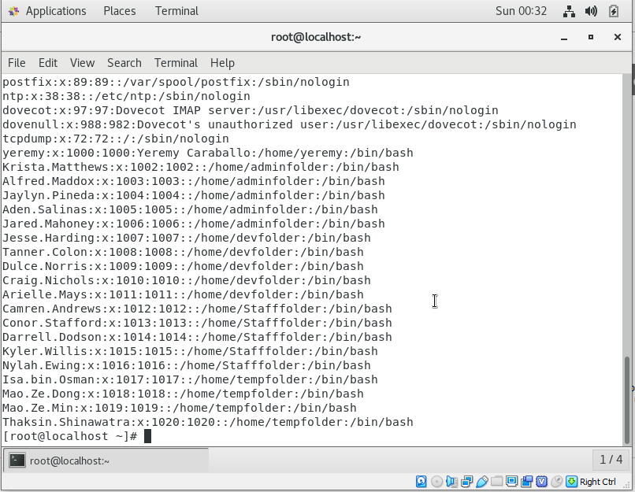

This is the following script I used in order to read from the file. I used the useradd because it was the lowest new user command that ubuntu would use. Also it transferred well over to CentOS because it was able to understand the script to make it easier. This automatically assigned a password to the users.

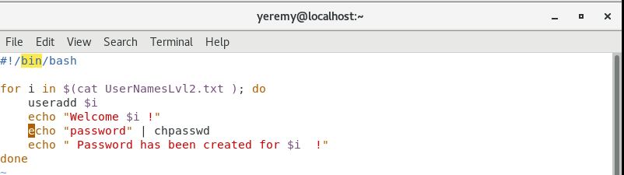

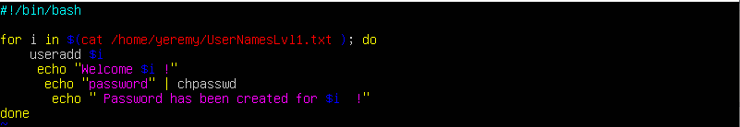

These are the groups I created in both servers which had users assigned to them. The groups had their own folder which certain users can access if they had permission.

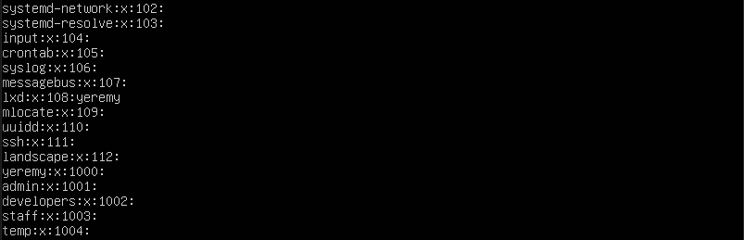

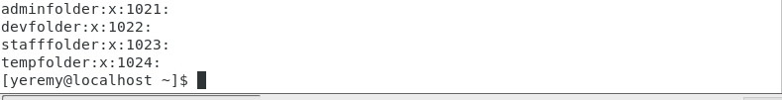

I attempted to setup the quota, but I am going to continue to do more research because I had an issue giving the specific user certain space using the quota. I attempted to do research but its very vague on what’s out there about quota on users. I will attempt to reach out to some peers but for now I will continue my research.

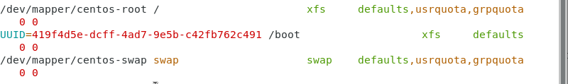

Link to Git Hub – I uploaded the code to my profile.

<https://github.com/yeremyc23/Linux-Scripting/blob/master/README.md>